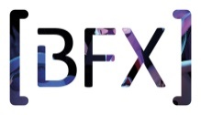
BFX Festival 2017
Initial Submission Form

1. Speaker Details
Name of Speaker: | Company Name:
Company Address:

Mobile Tel No: | E-mail address:
Work Tel No: | Website:

2. Submission Details:
Written synopsis (maximum 300 words):
(Must include the topic, related technique and case studies)

3. Further Information:
Please email this form to info@bfxfestival.com by 13th June 2017.
Studios/speakers who respond by the deadline and whose submissions are selected for the festival, will be given the option of a free recruitment stand at the BFX Careers Hub which takes place on the 6th October, saving £250.

All submissions will be reviewed by the festival committee and authors of successful submissions will be notified by 20th June 2017.

Thank you for your submission.
The BFX Festival Team

